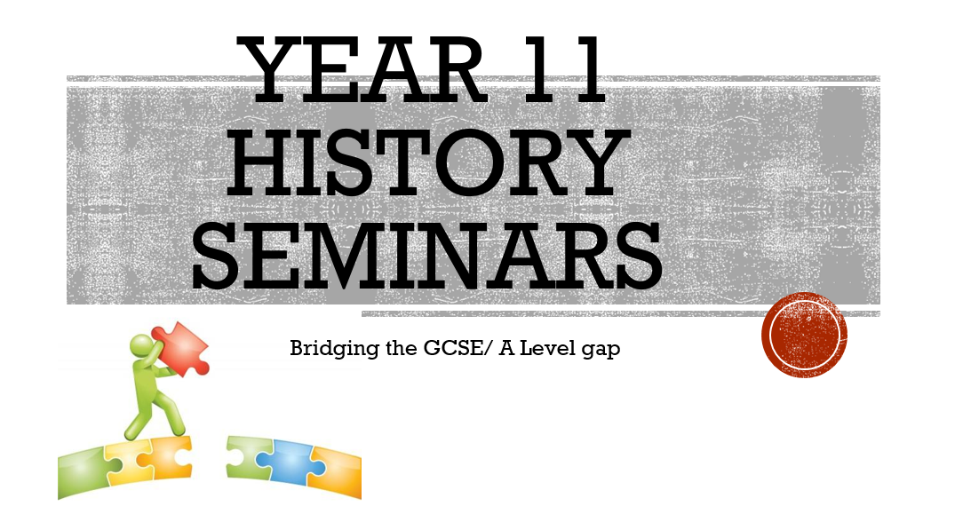

Don’t forget, anywhere you see this symbol there is some audio to listen to.
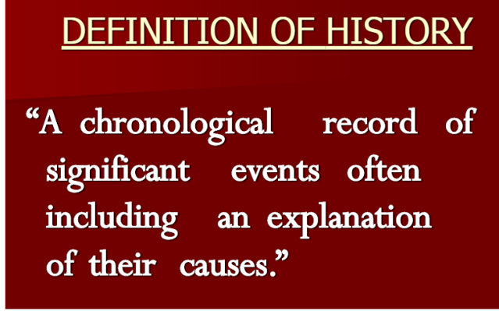
What do you think of this definition?
Strengths:
Weaknesses:

 | Strengths | Weaknesses
We are not makers of history. We are made by history. Martin Luther King
History teaches us the mistakes we are going to make.
Every true history must force us to remember that the past was once as real as the present and as uncertain as the future.
If you want to understand today, you have to search yesterday.
Study history, study history. In history lies all the secrets of statecraft.
Study history. Separate fears and prejudices from facts. Recognise facts from propaganda. Invest energy in fighting for what you believe in. Analyse harder where we are going and what you are doing about it. What do you really believe in? How much do we care?

Issues that need to be considered when studying history

From Gorbachev: On My Country and the World. Published in 1999. Translated from Russian.
Today we know much more about the October Revolution than did its participants and more than the heirs of the revolution in our country were allowed to know. Glasnost and perestroika have given us the opportunity to learn many fundamental facts about the revolution which had been classified or falsified - and about the decades after it. The disclosure of the truth that was begun under glasnost - even though it caused shock and aroused protest on the part of many people, and for many different reasons - became a stimulus toward reviving the moral health of our society.
Today, incidentally, a system of secrecy is being revived - not in relation to October but toward many subsequent events, including recent ones. Lies and half-truths have again become an essential part of politics. As in the past, this is a symptom of the unhealthy moral character of the regime.

The policy of glasnost in the perestroika era and its continuing, unstoppable momentum allow us to look at ourselves with open eyes, providing us with new knowledge about the many sided nature of October and its consequences, and enabling us to reflect on various aspects of post October developments in their true dimensions and significance.

Your interpretation of Coronavirus for future students of history:

