Year: 11&3/4 Geography Topic: Globalisation
Teams | Before you start today’s work, go to Teams and follow the instructions your teacher has given you!

Title: Globalisation & Brain Drain
Recap & post on padlet.  This Photo by Unknown Author is licensed under CC BY-SA | The evidence from last week’s lesson on ‘Globalisation & Natural Resources’ suggest that in the developing world (LICs) the extraction of natural resources is POSITIVE/NEGATIVE.  Post on the padlet link in Teams with your name at the top!

Click & play  This Photo by Unknown Author is licensed under CC BY-NC | 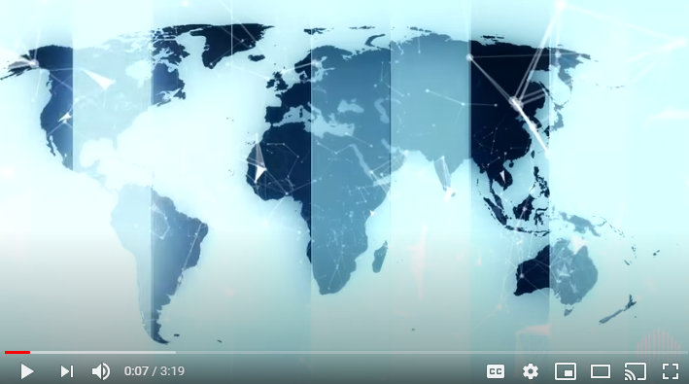

Read, think & respond in Teams  This Photo by Unknown Author is licensed under CC BY-SA | The flow of people again brings up the chicken-egg situation – what drives what?  Either way, it is clear that globalisation makes the movement of people around the world much easier. Not only can people travel really easily, they also remain connected to loved ones back home through technology which, for example, lets them communicate (e.g. WhatsApp, Skype, etc…) or which allows money transfer (e.g. PayPal or Western Union).  Making travel for work so easy and attractive has led to what we refer to as a brain drain: the emigration of highly trained or qualified people from a particular country. Countries around the world are competing for resources and prime among these is human capital (the skills, knowledge, and experience possessed by an individual). Attracted by a better standard of living and the promise of higher wages, skilled individuals are leaving their countries in search of opportunities elsewhere. When this individual is from a developing country, this can be especially damaging…  In Teams, add a comment to show an example of real life brain drain (it can be a personal experience & UK based), or a sporting analogy of an individual whose talent has led to them working/playing sport around the world.
Click & watch  This Photo by Unknown Author is licensed under CC BY-NC | We are aware of eastern eurpean migration, but what’s happening in developing countries? How will this trend impact development?

Watch  This Photo by Unknown Author is licensed under CC BY-SA | 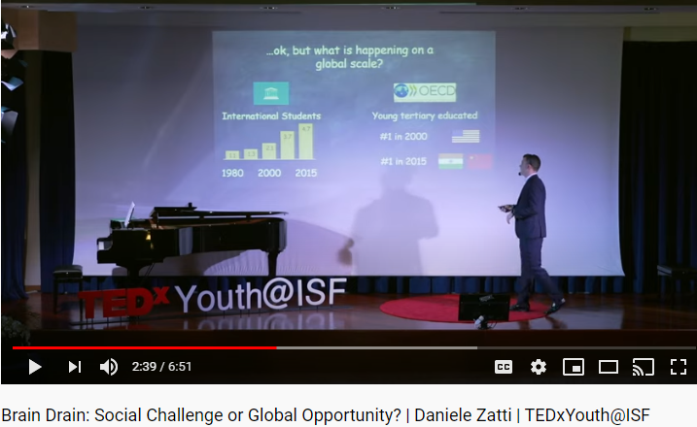

Discuss  This Photo by Unknown Author is licensed under CC BY-SA | ‘The brain drain’ is currently the most significant barrier to development in the developing world.  To what extent do you agree/disagree with this statement?  Post your answer in Teams!

Homework: | Click & listen!

