Year: 11&3/4 Geography Topic: Globalisation

Teams | Before you start today’s work, go to Teams and follow the instructions your teacher has given you!

Title: Globalisation & the environment
Spec check  This Photo by Unknown Author is licensed under CC BY-SA | 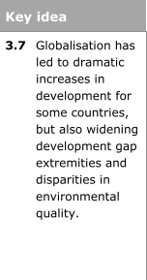

Click & play  This Photo by Unknown Author is licensed under CC BY-NC | Take the socrative quiz! Join the classroom MSDAYGR1

Read  This Photo by Unknown Author is licensed under CC BY-SA | It could be argued that globalisation and neo-liberalisation have  led to the privatisation of physical/natural resources,  such as water, minerals, oil, gas, wood and land, which has increased exploitation.  This causes tension between indigenous groups,  who seek to retain their sense of cultural identity and the links  to the landscape they are rooted in, and those who seek to make  economic benefit from the landscape or culture.  At GCSE you looked at the First Nations (indigenous communities) in Canada & tar sands  and how they are fighting economic development that threatens their land rights  in a number of areas.  We will develop this further with an examination of two further case studies.
Click & watch  This Photo by Unknown Author is licensed under CC BY-NC | 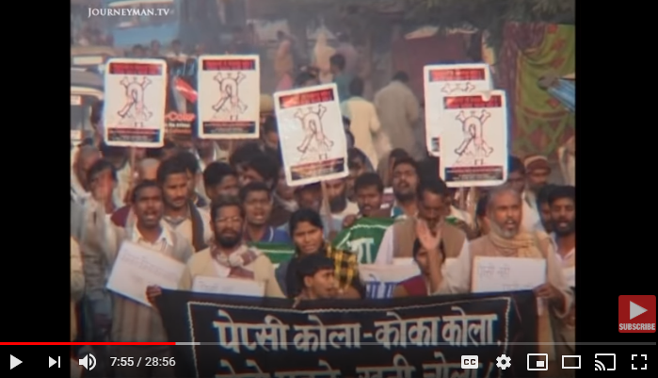

Read
This Photo by Unknown Author is licensed under CC BY-SA

Discuss  This Photo by Unknown Author is licensed under CC BY-SA | The evidence base that globalisation is predominately negative for the developing world.

Homework:

