Microeconomics Lecture 3 June 2020 Wednesday Period 3
Behavioural Economics
Framing and Nudges (from slides)
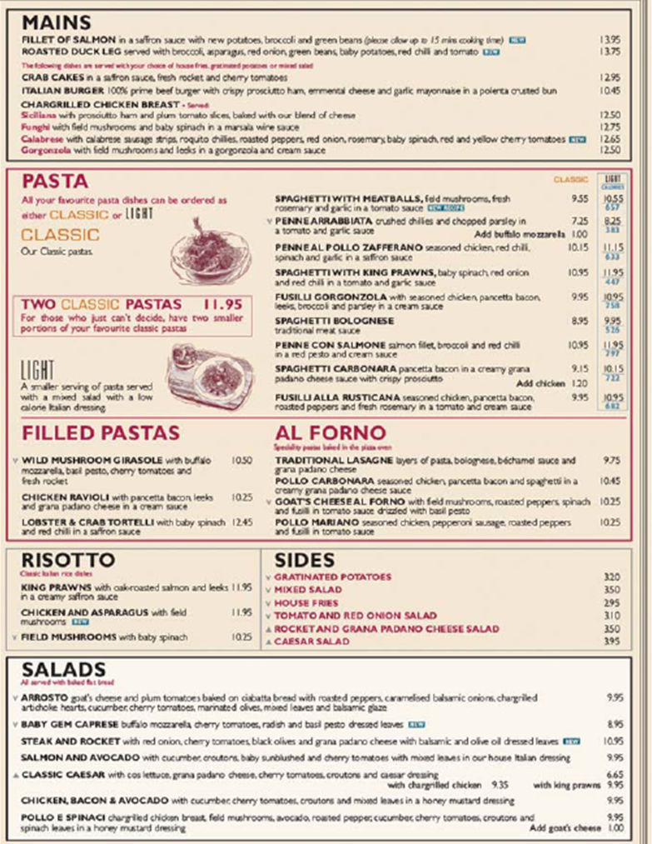

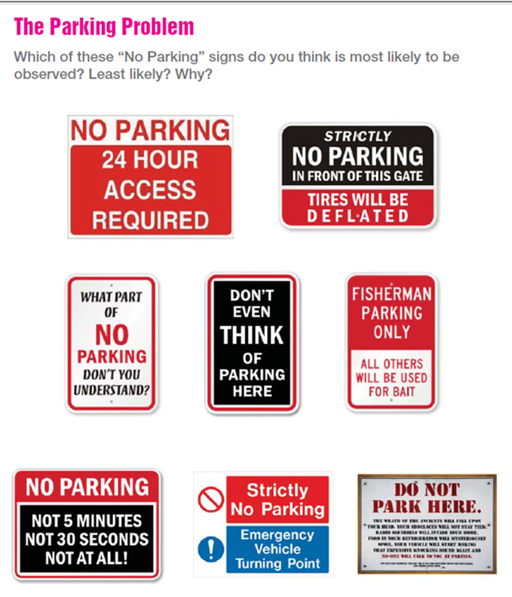

Clip 1 – Nudge Theory
www.youtube.com/watch?v=HeUX6LABCEA

Resource | Where to find it.
EconplusDal | https://www.youtube.com/watch?v=m4Mg0d9-t2E
Bounded Rationality | https://www.youtube.com/watch?v=4Lusy6Vmvh8&feature=youtu.be
Sneaky Supermarkets | https://www.nationalgeographic.com/culture/food/the-plate/2015/06/15/surviving-the-sneaky-psychology-of-supermarkets/

