Prescribed Visual Sources for Greek Theatre (H008/21 and H408/21)

This document has been produced to help reduce the preparation needed for the new AS/A Level Classical Civilisation specification (H008/H408), by providing potential websites where teachers can find images of the prescribed visual sources.

Theatre of Dionysus at Athens
https://commons.wikimedia.org/wiki/Category:Theatre_of_Dionysus
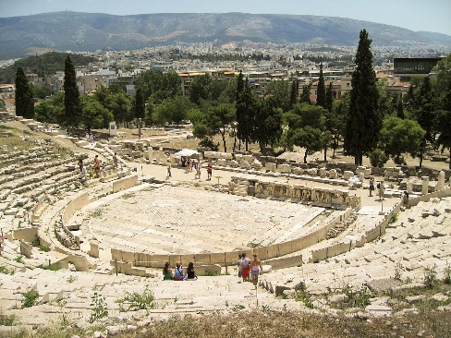
http://www.perseus.tufts.edu/hopper/artifact?name=Athens%2C+Theater+of+Dionysos&object=Building
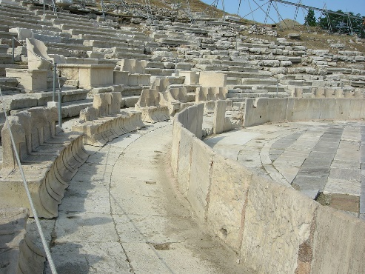
http://www.livius.org/pictures/greece/athens/athens-theater-of-dionysus/

Theatre of Thorikos, a coastal deme of Attica
https://commons.wikimedia.org/wiki/Category:Ancient_Greek_theatre_(Thorikos)
https://translate.google.co.uk/translate?hl=en&sl=de&tl=en&u=http%3A%2F%2Fwww.theatrum.de%2F227.html

Volute krater by the “Pronomos” painter, depicting team of actors celebrating, with costumes, masks, aulos-player, playwright, Dionysus, c.410 BC, in the Naples Museo Nazionale (3240)
http://cir.campania.beniculturali.it/museoarcheologiconazionale/thematic-views/image-gallery/RA84/view
http://www.beazley.ox.ac.uk/XDB/ASP/recordDetails.asp?id=3D02875A-C39F-47EC-B0C3-396D004855C7&noResults=&recordCount=&databaseID=&search=
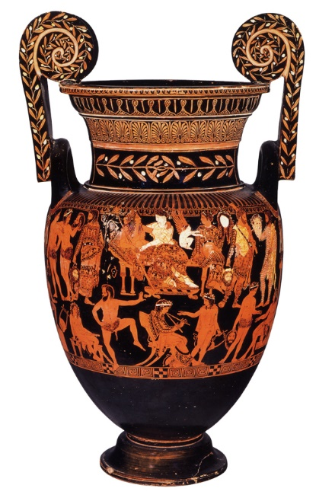
Pg 33 PS: 1.19

Bell krater by McDaniel Painter, “Cheiron Vase”, Cheiron and Xanthias slave – comic scene, steps & low stage, c.380–370 BC, in British Museum (1849,0620.13)
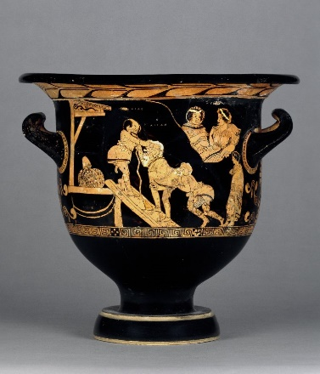
http://www.britishmuseum.org/research/collection_online/collection_object_details.aspx?objectId=463873&partId=1
Pg 45 PS:1.25

Red-figure column krater in mannerist style, “Basel Dancers”, tragic chorus in action, in front of stepped altar, c.500–490 BC, in Antikenmuseum, Basel (BS 415)
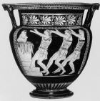
http://www.beazley.ox.ac.uk/XDB/ASP/recordDetails.asp?id=1451C241-DD83-4763-AFB6-786C657896FA&noResults=&recordCount=&databaseID=&search=
Pg 31 PS: 1.18

Black-figure oinochoe depicting two chorus-members dressed as birds, c.480 BC in British Museum (B509)
http://www.britishmuseum.org/research/collection_online/collection_object_details.aspx?objectId=463878&partId=1&searchText=b509&sortBy=&page=1
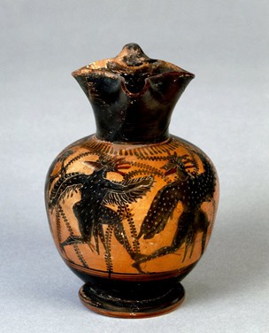
Pg 43 PS: 1.24

Red-figure bell krater by Schiller Painter, depicting scene with wine-skin & boots from Women at the Thesmophoria (Thesmophoriazusae), c.380–370 BC, in Martin von Wagner Museum, Wurzburg (H5697)
http://www.worldhistory.biz/uploads/posts/2015-09/625w-7.jpg
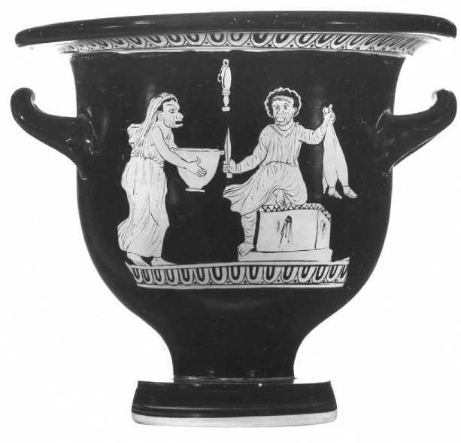
Pg 20 PS: 1.13

The death of Pentheus, red-figure kylix attributed to Douris, c.480 BC, in Kimball Art Museum, Fort Worth, Texas, USA
https://www.kimbellart.org/collection-object/red-figure-cup-showing-death-pentheus-exterior-and-maenad-interior
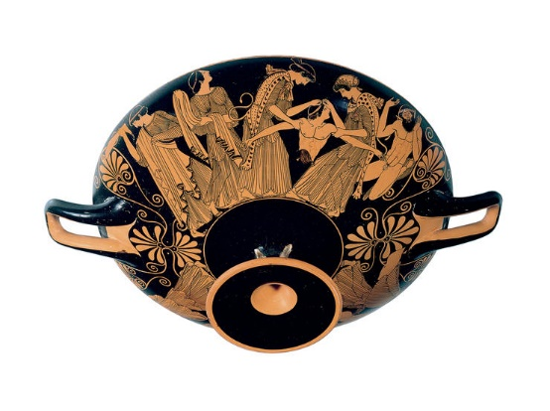
Pg 73 PS:1.32

Red-figure Volute Krater, “Choregos Vase” or “Comic Angels”, choregoi with Aegisthus and Pyrrhias, c.400–390 BC in Paul Getty Museum, California (No. 96.AE.29. J)
http://www.theatrum.de/2136.html
http://www.didaskalia.net/issues/vol5no1/beacham/image07.html
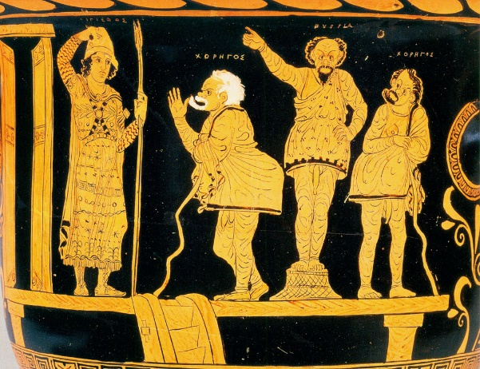
Pg 43 PS: 1.23

Red-figure calyx krater fragment by Capodarso painter, depicting Jocasta and Oedipus the King, c.330 BC in Museo Archeologico Regionale, Syracuse (“P. Orsi” 66557)
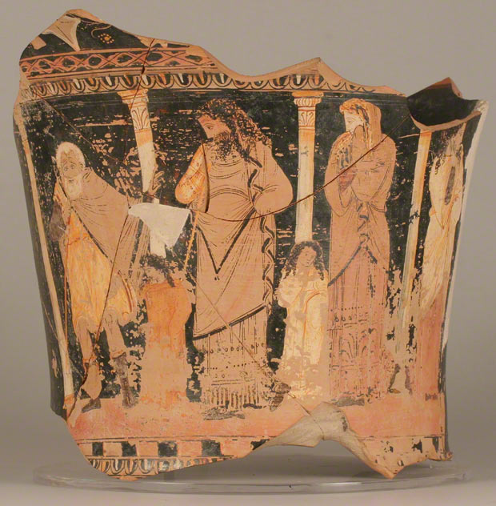
http://blogs.getty.edu/iris/art-and-performance-in-classical-greece-audio/

Red-figure Calyx Krater depicting Medea’s escape, c.400–380 BC, in Cleveland Museum of Art (91.1)
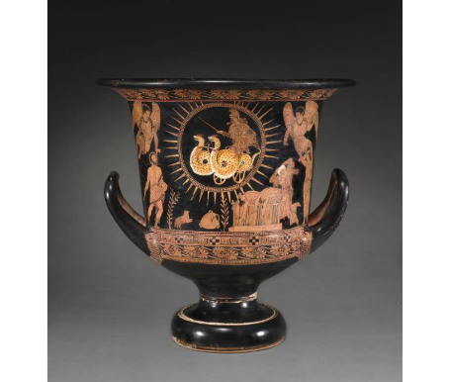
http://www.clevelandart.org/art/1991.1?f[0]=field_collection:826.

Pg 19 PS: 1.12

Pg 55 PS: 1.27

Red-figure pelike by Phiale painter depicting tragic actors dressing, c.450 BC, in Museum of Fine Arts, Boston (98.883-11)
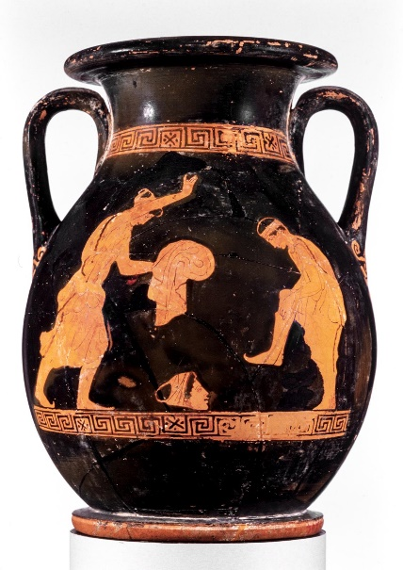
http://www.mfa.org/collections/object/two-handled-jar-pelike-with-actors-preparing-for-a-performance-153834
Pg 35 PS: 1.21

Red-figure ‘maenad’ stamnos by Dinos Painter, late 5th century, in Naples, Museo Nazionale Archeologico
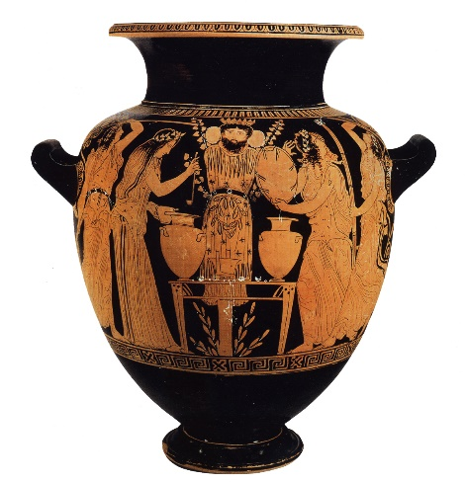
http://www.beazley.ox.ac.uk/tools/pottery/painters/keypieces/redfigure/dinos.htm
Pg 65 PS: 1.29

Red-figure vase fragment single actor possibly playing Perseus and two audience members/ judges, c.420–410 BC, Vlastos collection, Athens (ARV2, 1215, 1)
Also known as the “Perseus Dance vase” or “Anavyssos Perseus”
https://static.cambridge.org/resource/id/urn:cambridge.org:id:binary-alt:20160719184013-60672-optimisedImage-76028fig5_9.jpg
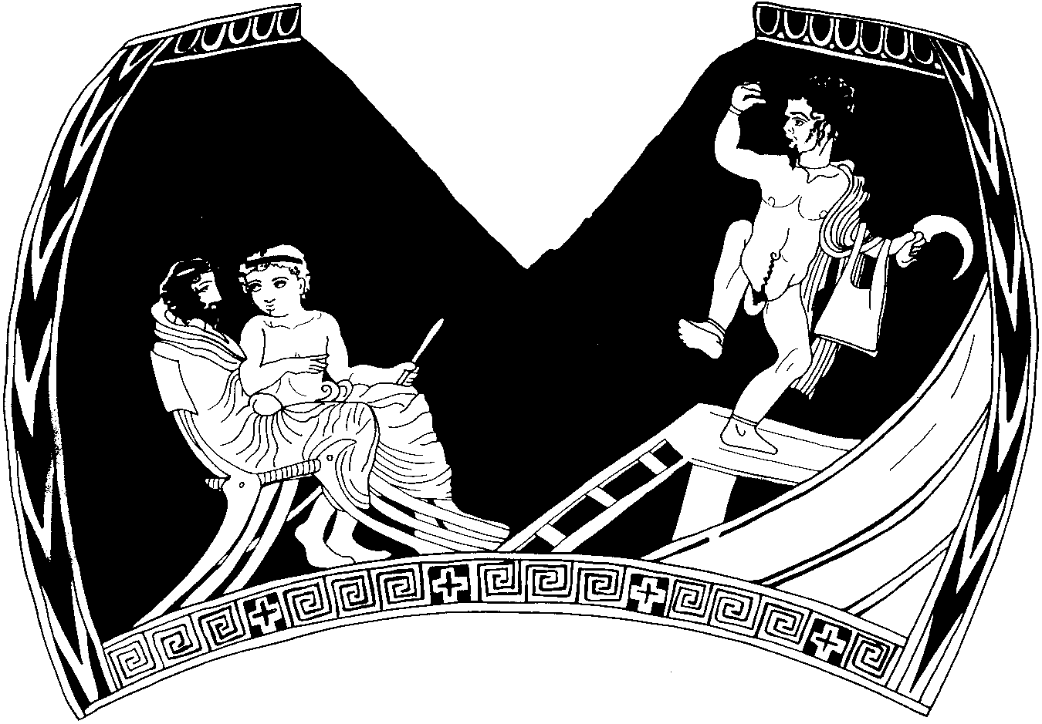

OCR Resources: the small print

OCR’s resources are provided to support the delivery of OCR qualifications, but in no way constitute an endorsed teaching method that is required by OCR. Whilst every effort is made to ensure the accuracy of the content, OCR cannot be held responsible for any errors or omissions within these resources. We update our resources on a regular basis, so please check the OCR website to ensure you have the most up to date version.

