AS-Level Classics 'Hit the Ground Running’

salvete, Classicists. Welcome to the Salesian College’s Classics Department.

It is highly advised that you prepare for the AS-Level Classics course by completing the following tasks over the summer:

- Join the edmodo group for AS level Classics. Do this within the next 7 days, as the group will lock and the code will change. Go to www.edmodo.com and enter the passcode 4vi2yk. Please email me if the code has expired at boylem@salesian.hants.sch.uk
- Locate and read as much as you can of the key texts which we will be studying in Year 12, either electronically or paper. The first one is an ancient epic, from the famous Greek writer, Homer, called the ‘Odyssey’ translated by EV Rieu in paper copy. Alternatively, there is a free online copy translated by AS Kline. https://www.poetryintranslation.com/PITBR/Greek/Odhome.php You will be provided with a paper copy in September, however, as you will be expected to annotate these texts, it is optional for you to purchase your own paper copy. The ISBN code which you can use to search for the paper copy online is 978-0-140-44911-2. 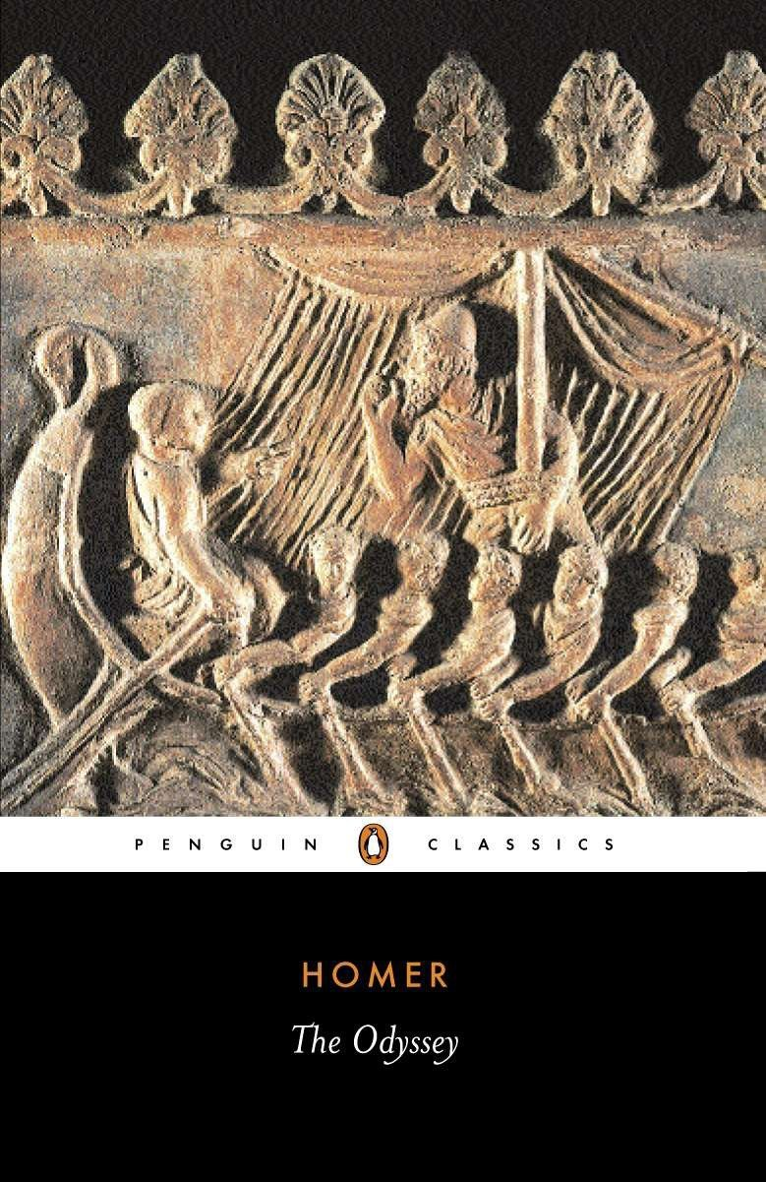
Aim to have skim read the entire book by September. Read it quickly, so as to gain an overview. There are many online summaries which you can read before, during or after: but not instead of! It is a good idea to write out your own short summaries of each chapter after reading.

The other half of the course is on Greek Theatre, where we study the fascinating Comedies and Tragedies of the Athenians. You may find these challenging, but do have a go at reading them before the course starts:

Comedy: https://www.poetryintranslation.com/PITBR/Greek/Frogs.php
Tragedies: https://www.poetryintranslation.com/PITBR/Greek/Bacchae.php
https://www.poetryintranslation.com/PITBR/Greek/Oedipus.php

I look forward to seeing you in September. Remember that you do not have to have read this book before or studied GCSE Classics to complete this AS-Level course. Happy reading and enjoy your summer.

Mr.Boyle
Head of Classics

