Dear Year 12 Art student,
Summer Homework Project.
To ensure Year 12 Fine Art students are prepared for the start of their AS Studies, I would like you to start exploring your own ideas and influences in Art. I am expecting students to begin creating a Scrapbook of Inspiration where you are thoughtfully collecting and creatively presenting a range of images that may inspire your own art work.

These images should be sourced from a variety of places, for example from the internet, from magazines, photographs and art galleries (it would be great if you can visit one over the summer). There is no particular theme other than “Inspiration” but students should definitely look for artists and photographers whose work they feel they have a connection with.
The scrapbook should include student’s own sketches to accompany their research as well as annotation and analysis as to:
- why these images are inspirational
- how they may have been made (materials and techniques)
- how they can influence the student’s own work and development as an artist.
Students will have to purchase (or make) their own scrapbook and it should be a fun and creative, personal investigation.
Some examples of scrapbook pages are included below:

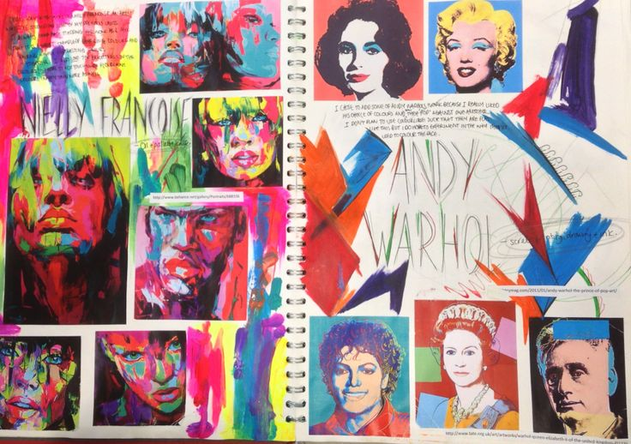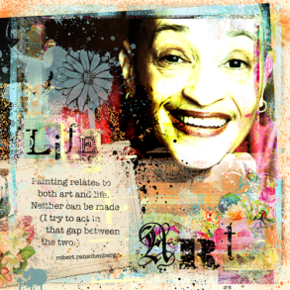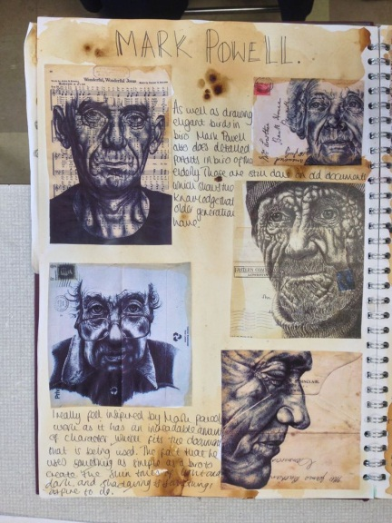

I look forward to seeing your work in September.

