Bridging Booklet

What is this booklet for:
This is simply designed to be a bridging Chemistry booklet.
It has work to prepare you for the A level you are starting in September.
It contains a series of topics that you will have covered in GCSE and it is then extended into some A level standard work.
How to use the booklet:
- Read over the explanation notes and examples
- Look over work from your GCSE exercise books and revision guides
- Look on the internet for other guidance, google the chapter titles!
- COMPLETE the Tasks in the ANSWER booklet section.

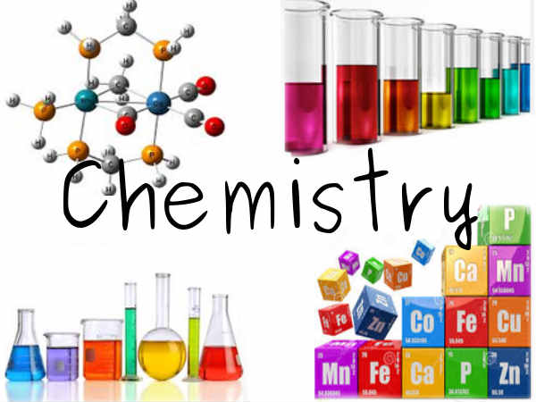

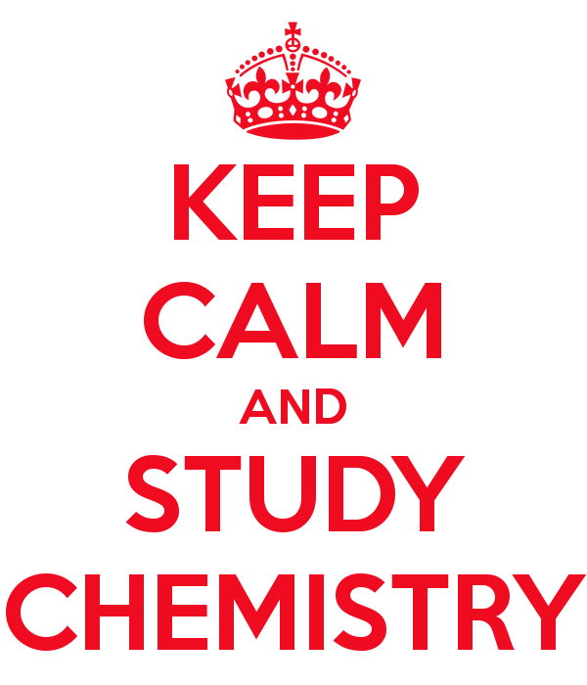

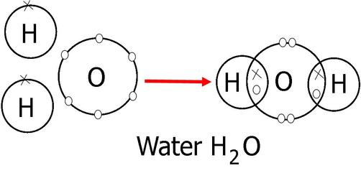
Example of a typical covalently bonded compound
Water
Chapter 1
Bonding
This is a cornerstone of chemistry, when elements react together they form new compounds which have two or more elements chemically joined.
There are two main types of chemical bond.
Ionic -----between a Metal and Non-metal
Covalent ------between Non-metal and Non- metal

Task 1
Decide if the compounds below are Ionically or covalently bonded together and why?
- Ammonia NH₃

- Zinc Oxide ZnO

- Methane CH₄

- Benzene C₆H₆

- Potassium Dichromate K₂Cr₂O₇

Ionic Bonding
This is an ELECTROSTATIC ATTRACTION between 2 oppositely charged species called IONS.
The compound is formed is neutral, which means it has no overall charge.
i.e. it has an equal amount of positive and negative charge from the different ions that are making it up.
How are IONS made?
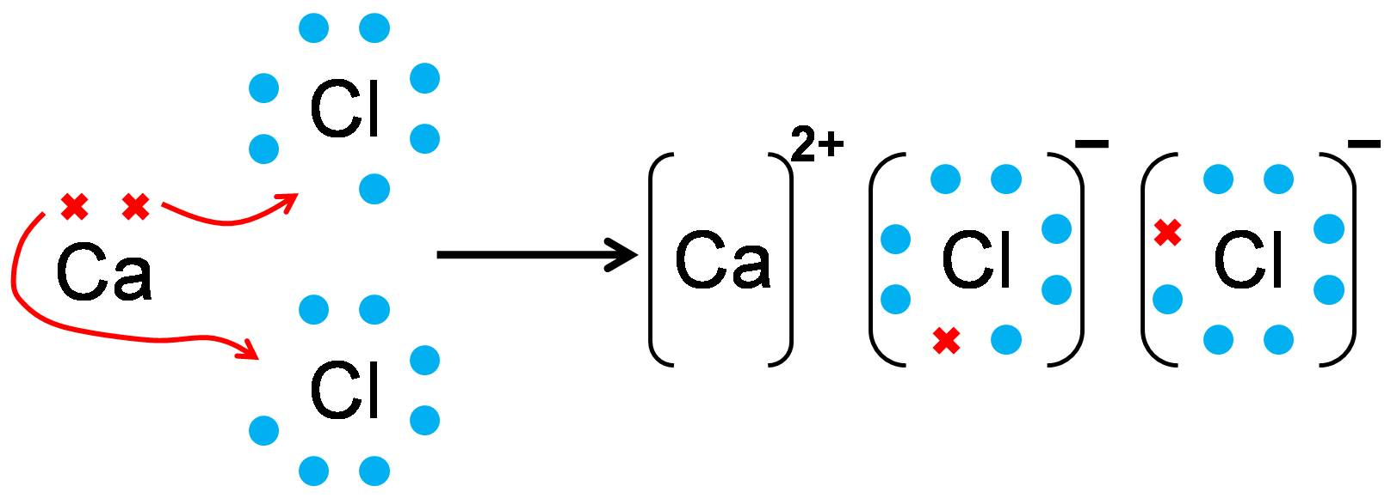
This is seen by the diagram above:
METALS: (Calcium) | NON- METALS (Chlorine)
They form Positive ions as they lose their outer electrons to form a FULL OUTER SHELL. | They form NEGATIVE ions as they gain electrons to form a FULL OUTER SHELL.
Calcium 2 electrons in its outer shell as an element so LOSES 2 electrons to become a 2+ ion | Chlorine has 7 electrons in its outer shell so will GAIN 1 electron to become a 1- ion

Task 2
Draw out Atom and Ions for the following ionic compounds (like the calcium Oxide diagram above)
- Aluminium Oxide

- Lithium Oxide

- Barium Nitride

Formula of Ionic compounds
When we form an Ionic compound we have oppositely charged ions attracted together so that a neutral compound is formed.
This means there is a balance between the positive metals ions and negative non-metal ions.
You swap the NUMBERS of the charge over
If a 1 you ignore it
If get 2 numbers the same ignore them
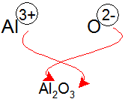
Aluminium Oxide made from Aluminium ions and Oxide ions.
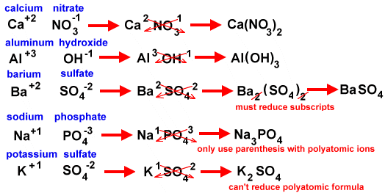
Other examples above( don’t worry about the writing in red)
Task 3 ( Use appendix I)
Using the table of common ions work out the formula of the following ionic compounds.
- Silver chloride
- Lithium sulphate
- Ammonium Hydroxide
- Potassium Dichromate
- Iron (II) Nitrate

Formula interpretation
When we have calculated the formula of a compound it is important we can interpret the information about the number of atoms and types of elements in the compound.
e.g.
Calcium Carbonate
CaCO₃
1 Ca
1 C
3 O

Task 4
Look at the following compounds and work out the number and type of elements in the compound.
- AgNO₃

- PbCO₃

- SnCl₂

- Mg(OH)₂

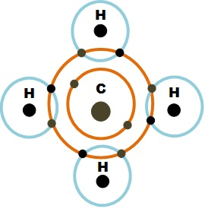
Covalent bonding
The covalent bond is made up from non-metal atoms that want to bond together.
Covalent bonds are made from the atoms sharing their electrons to get a FULL OUTER SHELL.
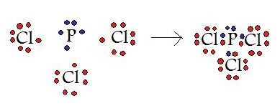
The above example shows,
Phosphorus in group 5 with 5 outer electrons sharing 1 electron each with a chlorine atom which is in group 7.
Both the Phosphorus and Chlorine NOW have their FULL OUTER SHELL.
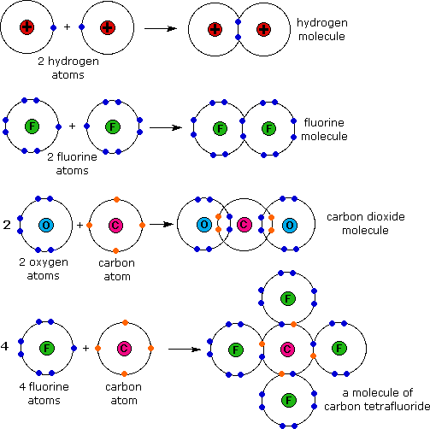
More examples

The example shows a series of covalently bonded molecules where the atoms have all got a FULL OUTER SHELL.
Please note
DOUBLE BOND on the CO₂ molecule .

The 4 SINGLE BONDS from the carbon attached to each individual F in the CF₄ molecule.

EXT Line diagrams

These are simpler versions of the shown DOT-CROSS diagrams where you show each bond ( PAIR of ELECTRONS) as a line between the atoms in the molecule

e.g.

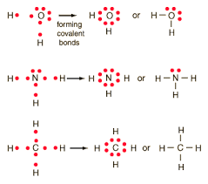
The extra pair of electrons that are not involved in the bonds are called LONE PAIR of electrons.
These are shown by the pair of ‘dots’ around the central atom.

Task 5
Draw out the Dot/ Cross diagrams and Line diagram of the following molecules:
- Ethane C₂H₆
- Propene C₃H₆
- Hydrogen Peroxide H₂O₂
- Hydrogen Sulphide H₂S
Chapter 2
Structure

There are 4 main structures you need to be aware of
- Metallic structure
- Giant Ionic
- Giant covalent / Macromolecular
- Simple Molecular

- Metallic
This occurs in metals.

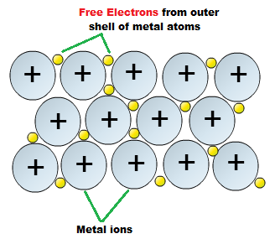

These are strongly bonded structures which have HIGH boiling and melting points.
They CAN conduct electricity due to the FREE ELECTRONS.

2 Giant Ionic
This occurs as a LATTICE of IONS electrostatically attached together with the positive ions being attracted to the negative ions.
It occurs in Ionically bonded compounds.

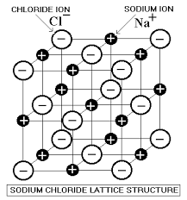
3 Giant covalent / Macromolecular

This occurs in a select number of covalently bonded compounds which have ALL their atoms covalently bonded together in a large structure.
Key examples are ALLOTROPES of carbon ( look up what Allotrope means!) and silicon dioxide

Diamond Silicon Dioxide Graphite

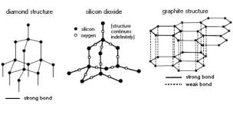
EXT
Buckminster Fullerene

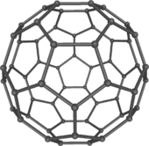
This is a C₆₀ molecule in the shape of a football.
They were discovered in the UK in 1985 and the chemists involved won the Nobel prize in 1996.

4) Simple Molecular

This occurs in covalently bonded molecules which have STRONG covalent bonds inside the molecules
But
Much weaker INTERMOLECULAR bonds between the molecules.
The three types of INTERMOLECULAR bond/ force are:

- Van Der Waals
- Permanent Dipole
- Hydrogen Bond

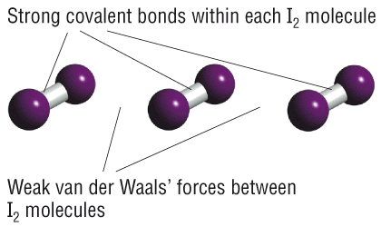

Task 6
Research task
Find out what the trend in melting/ boiling point is for Na-Mg-Al ( the metal in the third period)
Explain why there is this trend ( linked to their structure)

http://www.creative-chemistry.org.uk/alevel/module1/trends8.htm

( basic source exemplar )

Chapter 3

Equations

We will be most interested in BALANCED symbol equations.
These show us exactly what elements are in the reactants and the products and we need the SAME amount on both sides of the equation.
Example

Calcium + Oxygen Calcium Oxide

Ca + O₂ CaO

This is not balanced,
So we need to ADD large numbers in front of the formula given to balance it.

Firstly
Ca + O₂ 2 CaO
Added a 2 in front to get the
right number of oxygen’s.
But
This means we know have too many calcium’s.
So we now need to add
2 on this side as well
2Ca + O₂ 2CaO

It is now a Balanced equation.

Task 7
Balance the following equations:
- N₂ + H₂ NH₃
- CH₄ + O₂ CO₂ + H₂O
- Na + H₂SO₄ Na₂SO₄ + H₂
- SO₂ + NaOH Na₂SO₃ + H₂O
- C₂H₅OH + O₂ CO₂ + H₂O

State symbols

These are linked to the three states of matter
- Gas (g)
- Liquid (l)
- Solid (s)

Also we have (aq) for a solution.

EXT
Ionic compounds in solutions

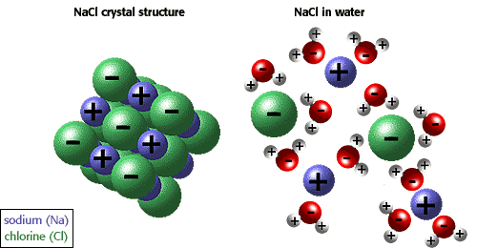

When we dissolve an ionic compound it is the separate ions in the compound being split apart and bonded to the water.

NaCl (s) + aq NaCl (aq)

Is in fact
Na+ (aq)

Cl- (aq)

Chapter 4 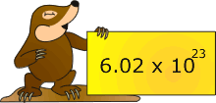

Mole work.

In its most basic form the ‘MOLE’ is just a word used to describe a number.

e.g. Couple 2
Dozen 12
Mole 6.02 x 10 ²³ ( 602000000000000000000000)

Why this large number?
It was found that this number of ATOMS of any element is equal to the MASS NUMBER of this element in grams.
e.g.
6.02 x 10 ²³ carbon atoms is equal to 12g
6.02 x 10 ²³ neon atoms is equal to 20g

This leads to the FIRST mole equation.

Moles = Mass
R.A.M (relative atomic mass)
e.g.
How many moles are there in 24g of carbon?

Moles = Mass
R.A.M

Moles = 24
12

Moles = 2 moles of carbon

Task 8
Calculate the number of moles in the following elements?
- 59 g of cobalt
- 4.14 g of lead
- 1.08g of gold

This can get increased very quickly to include compounds and not just elements.

In this we use a very similar Mole equation:

Moles = Mass
R.F.M This is the Relative formula mass

e.g. H₂O

H + H + O

1 + 1 + 16 = 18

e.g.
How many moles are their in 88g of carbon dioxide?

Moles = Mass
R.F.M
CO₂
= 88
44 C + O + O

= 2 mole 12 + 16 + 16 = 44

NOTE- Good practice
It is always good practice to start with the equation in word form then put the numbers in from the questions
It is also good practice to show how you have worked out the RFM so if there is an error you can still get method marks.

Task 9
How many moles are there in the following:
- 62 g of sodium Oxide Na₂O
- 174 g of lithium bromide LiBr
- 3.2 g of oxygen
- 1.24 g of Ammonia

Changing the equation
We can have this mole equation in a simple MAGIC TRIANGLE and easily change the aspect we are trying to work out.

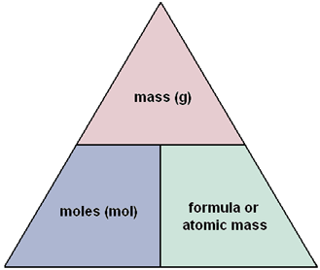

So we may get asked to calculate the Mass or Relative formula mass.

Task 10
Calculate the :
- Mass of 2 moles of calcium metal
- 0.25 moles of lead carbonate PbCO₃
- The formula mass of a compound which has 0.5 moles of mass 14g

EXT
Harder question
Task 11
250g of hydrated copper sulphate ( CuSO₄ .x H₂O ) is collected and a student want to calculate the number of moles of water attached to the copper sulphate, the x value.
The student completely dried the copper sulphate and the new mass was found to be 160g
- Calculate the moles of copper sulphate
- Calculate the mass of lost water
- Calculate the number of moles of lost water
- Therefore deduce the formula of the hydrated copper sulphate.

Moles and solution

When we dissolve a solid in water we create a solution.
We use a different mole equation to calculate the moles in the solutions we create.

Molarity / M
Mol/dm³ ml or cm³

Moles = Conc x Vol
1000

e.g.
How many moles are there in 250 cm 3 of 0.1 M Hydrochloric acid ?

Moles = Conc x Vol
1000

= 0.1 x 250
1000

= 0.025 Moles

This equation can again be moved around if you have to calculate the concentration using the moles and volume.

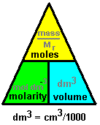

Task 12
- Calculate the moles in 40 ml of 5M of sodium hydroxide solution
- What is the concentration when you dissolve 2 moles of acid in 100ml of water
- How many moles are there in 500ml of 0.1 mol/dm³ of salt solution
- What is the concentration of 0.25 moles of alkali in 25 ml
EXT
Combining our work

We often need to combine this work on moles and work out the mass of a solid we need to make up a set concentration of a solution.

I.e. we want to make 100ml volume of a 0.5 M solution of sodium Hydroxide, how much mass do we need to dissolve?

- How many moles are in this solution,

Moles = Conc x Vol
1000

= 0.5 M x 100ml
1000

= 0.05 Moles of sodium hydroxide in solution

- What mass do we need for that many moles,
NaOH
Na + O + H
23 + 16 + 1 = 40

Mass = moles x RFM

= 0.05 x 40

= 2 g

So we will need to dissolve 2 g in the 100ml to make the required solution concentration of 0.5M.

Task 13
- How many grams of potassium oxide (K₂O) are needed to make 100ml of a 0.5M solution ?
- What is the concentration of a solution when we dissolve 730g of hydrochloric acid in 350 cm³?
- What is the mass of calcium oxide, CaO needed to make a 250 ml volume of 0.5 M solution?
NOTE- HINT
Keep looking carefully at the units
Ml= cm³ for volume mol/dm³ = Molarity =M for concentration

Molar Ratio

This is the link between the balanced symbol equations and the amount of moles of each substance in the reaction.
Simply it is the ratio of the numbers in front of the compounds in the balanced symbol equation.

e.g.

2Ca + O₂ 2CaO

In this equation the Molar ratio is:

2 : 1 2

Means:

2 moles of calcium will react with 1 mole of oxygen and we will make 2 moles of the calcium oxide.

As it is a ratio these numbers can be varied,

So if we actually had 10 moles of the calcium?

2 : 1 2 original ratio
10
10 : 5 10

So 10 moles of the calcium would react with 5 moles of the oxygen and form 10 moles of the calcium oxide

Or if we wanted to make 0.25 moles of the calcium oxide

2 : 1 2 original ratio
0.25
0.25 : 0.125 0.25
We would need 0.25 moles of the CaO

Final mole equation work

We are often asked to calculate how much we will produce in a reaction from a certain starting amount of reactants, or how much reactants we will need to make a set amount of products.

We put together the :
  - Molar ratio work with the balanced equation
  - The different moles equations

NOTE
If it involves a SOLID it is …

If it involves a solution it is ..
e.g.
Calcium oxide reacts with water to form calcium hydroxide.
CaO + H₂O Ca(OH)₂
If I started with 28g of the calcium oxide what mass of calcium hydroxide would I make, and if it was in 100ml of water what would its concentration be

1 : 1 1 Molar Ratio
CaO + H₂O Ca(OH)₂
28g
Moles = Mass
RFM
Ca(OH)₂
Ca + O + H + O + H
40 + 16 + 1 + 16 + 1 = 74
= 28
56
=0.5 moles

0.5 0.5 0.5 New molar ratio

Mass = Moles x RFM
= 0.5 x 74
= 37g

And the solution concentration would be:
0.5 moles
100ml

Conc = 1000 x mole
Vol

Conc = 1000 x 0.5
100

Conc = 5 mol/dm³

Task 14

- Calcium cyanamide CaCN₂ reacts with water to form calcium carbonate and ammonia
CaCN₂ + 3H₂O CaCO₃ + NH₃
What mass of calcium carbonate is formed if 20g of the CaCN₂ is reacted with excess water.

- Magnesium burns in air to make magnesium oxide
2Mg + O₂ 2MgO
What mass of magnesium would you need to create 0.8g of magnesium oxide powder.

- Iron reacts with water to form iron oxide and hydrogen
3Fe + 4H₂O Fe₃O₄ + 4H₂
If the student starts with 1.68g of iron and it undergoes a complete reaction
- Number of moles of iron started with?
- Moles of tri Iron oxide formed
- Mass of tri iron oxide formed
- The concentration of this solution if we had 500ml of water in the reaction?

- 25 ml of 0.1 M HCl reacts with 50ml of NaOH solution fully
What is the concentration of the NaOH solution.
HCl + NaOH NaCl + H₂O

Chapter 5

Organic chemistry

This is a branch of chemistry that looks at compounds of carbon chained molecules.
The main source of these compounds is CRUDE OIL.
We FRACTIONALLY DISTILL this to separate it out into different FRACTIONS which have similar boiling points, size and properties.

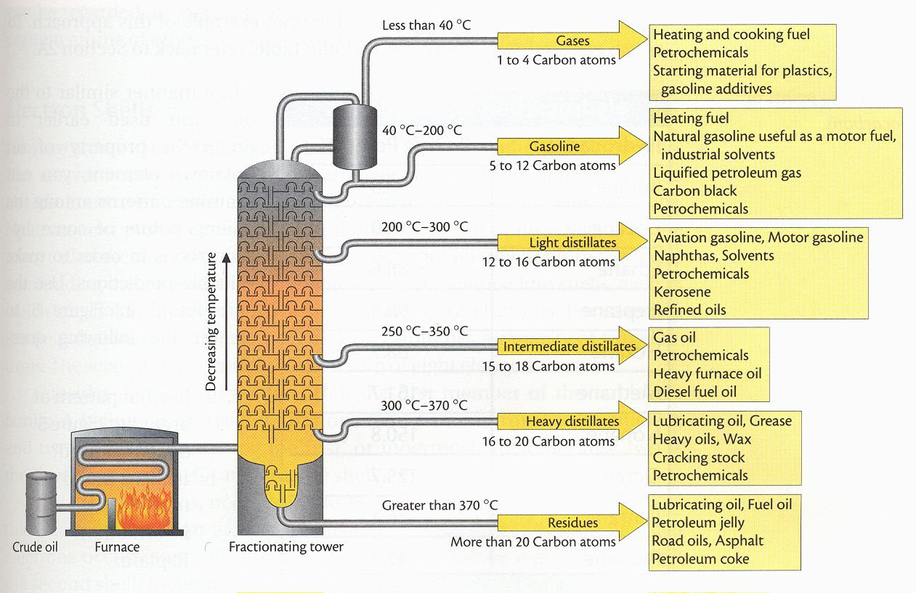

Task 15
Imagine you are a small CH₄ molecule in crude oil and you are being fractionally distilled,
What happened to you?
Why?
What happens to other molecules at the same time?
Why?
USE correct technical language to explain what’s going on.

Types of organic compound

There are lots of different types of organic compound which are based upon their FUNCTIONAL GROUPS or parts of the compound which determine how they react.
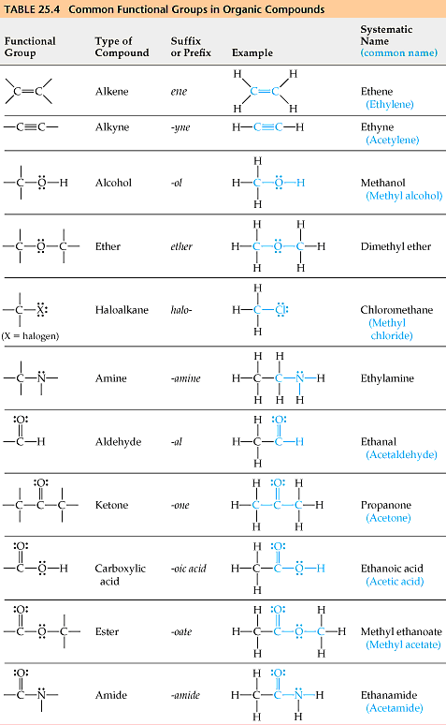

The table shows the most common functional groups with examples and naming ideas.

Another aspect of organic compounds is the SERIES (called HOMOLOGOUS SERIES) you have of compounds which all have the same functional group.
These all increase by –CH2- each time and have a common pattern of naming linked to the number of carbons in the compound.

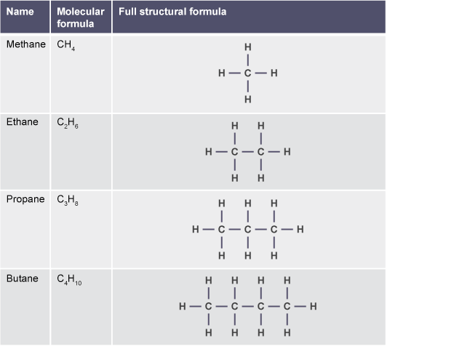

Task 16
Research
What are the FIRST 10 stem names for organic compounds
using alcohols as an example write out the molecular formula for the first 10, draw out the full structural/ displayed formula for the first 10 and names then as well.
(HINT complete a table like one above but for the first 10 alcohols!)

Chapter 6

Calculations on efficiency of reactions.
There are two main methods that are used to look over the efficiency of chemical reactions.

- Atom economy
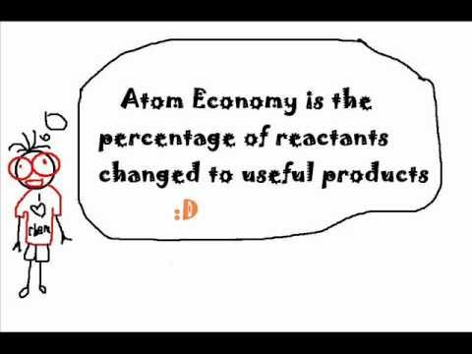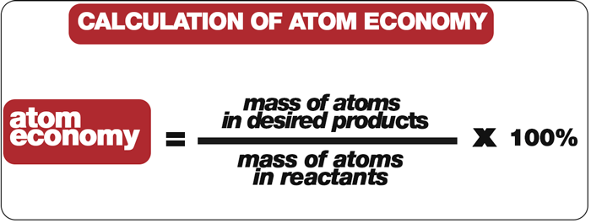

This is a measure of the useful products compared to all the products.
e.g.
Ethanol is decomposed into useful ethane and waste water.
Ethanol Ethene + Water
C₂H₅OH C₂H₄ + H₂O
RFM 46 28 18

Atom economy = mass of useful product x 100
mass of all reactants
= 28 x 100
46
= 60.9%
Task 17
What is the Atom economy in:
- Hydrogen is used in synthesising ammonia and is made on a large scale from reacting methane with water
methane + water ==> hydrogen + carbon monoxide
CH₄ + H₂O ==> 3H₂ + CO
- In the blast furnace where we form Iron .
Fe₂O_{3(s)} + 3CO_{(g)} ===> 2Fe_{(l)} + 3CO_{2(g)}
2) Percentage yield
This is the second method we use to calculate the efficiency of the reaction. This gives an idea of what is actually formed in reality as compared to what we would expect to be formed.

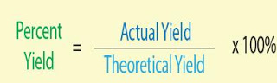
NOTE
You are often given the actual amount you form BUT you have to work out the theoretical amount from a mole calculation.

e.g. Ethanol is decomposed into useful ethane and waste water.
Ethanol Ethene + Water
C₂H₅OH C₂H₄ + H₂O
We create 1.4 g of the ethene from a starting mass of 4.6g of ethanol, what is the percentage yield.
CALC Moles = Mass
RFM

Moles = 4.6
46
= 0.1 moles 0.1 moles : 0.1 moles
Mass = Moles x RFM
= 0.1 x 28
= 2.8 g
This is the theoretical yield amount
i.e this is the full amount that could possibly be formed

Final calc percentage = Actual x 100
yield Theoretical
= 1.4 x 100
2.8
= 50%
Task 18
1) When 5.00 g of KClO₃ is heated it decomposes according to the equation: 2KClO₃ → 2KCl + 3O₂
a) Calculate the theoretical yield of oxygen.
b) Give the % yield if 1.78 g of O₂ is produced.
c) How much O₂ would be produced if the percentage yield was 78.5%?
2) The electrolysis of water forms H₂ and O₂.
2H₂O → 2H₂ + O₂
What is the % yield of O₂ if 12.3 g of O₂ is produced from the decomposition of 14.0 g H₂O?
Appendix I
Common ions

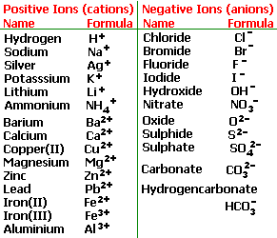

Appendix II
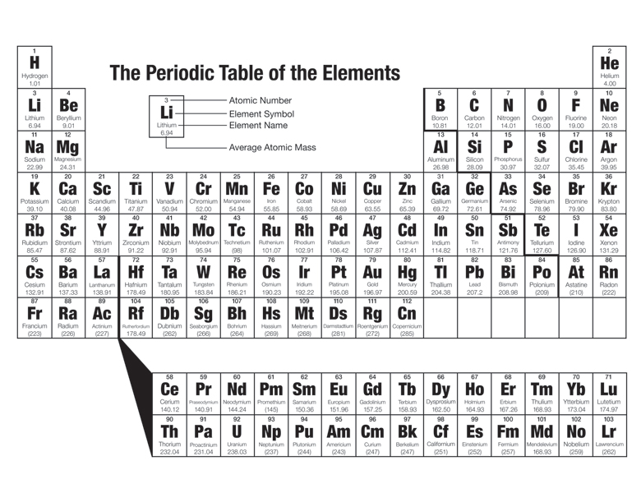
Periods are Horizontal across the table
Groups are vertical down the table
Group1 –Alkali metals 7 Halogens 8 Nobel Gases

